**EX NO 2: DATE:29.01.2025**

**NAME:SANJAY G**

**ROLL NO:230701286**

**CHUNKING**

**AIM:**

To create a memory recall task game using chunking method in figma.

**PROCEDURE:**

1. **Home Screen (It contains Instruction Page) Step 1: Create a Frame:** 
   * In Figma, create a new frame (File → New Frame). Set the size to 1024x768px for a standard desktop view.

**Step 2: Add Instructions:**

* + Use the Text Tool (T) to add a heading like “Memory Recall Task” • Add a smaller body of text with instructions such as:
  + “You will be shown several groups of icons or text. After viewing, recall the items you remember”
  + Use the Text Tool (T) to add more detailed instructions like “You will have 5 seconds to view the items. Then, recall them in the next screen.”

**Step 3: Start Button:**

* + 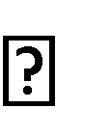Create a button at the bottom of the screen. To do this: Draw a Rectangle (R) for the button.
  + Use the Text Tool (T) to add “Start.”
  + Style the button (color, border radius) to make it stand out.
  + Use Figma’s Prototyping Tools (top bar → Prototype) to link this button to the next screen (Chunking Phase).
  + You can also use interactive components like hover effects for More realism.

**OUTPUT:**

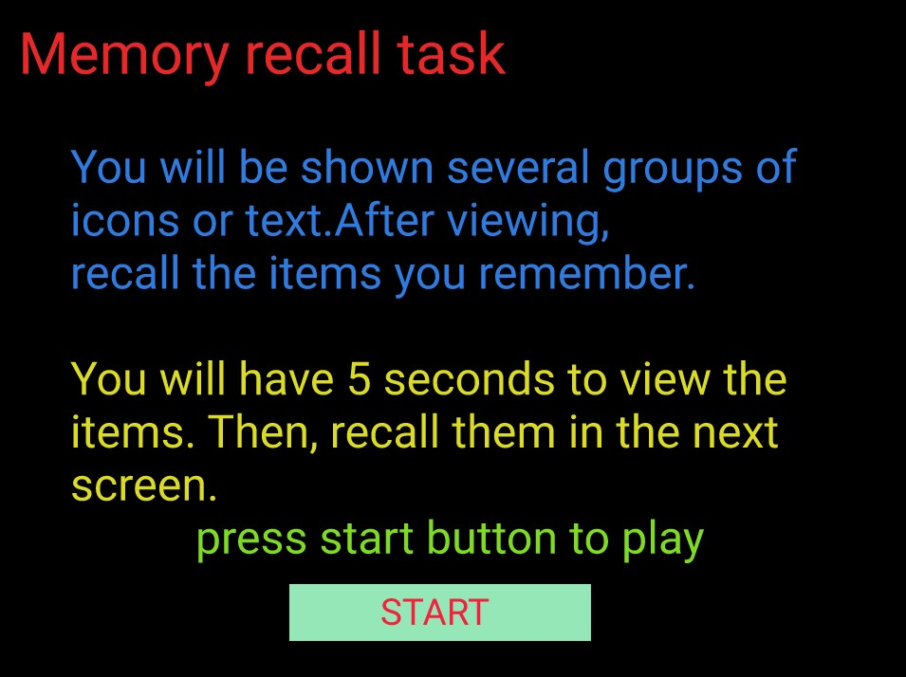

1. **Chunking Phase (It Display Chunked Items) Step 1: Create a New Frame:** 
   * Create a new frame for the Chunking Phase (the second screen). This frame will display the icons or text.

**Step 2: Design Chunked Items:**

* + Use icons or text blocks that users will have to recall. Import them from assets by searching “icons”.

**For Chunking with Borders:**

* + Group 3-5 icons or text together in a box (use the Rectangle Tool (R))

* + Space these chunks out with some empty space in between them to ensure users can identify each chunk.

**Step 3: Set the Viewing Time:**

* + Time Simulation: Figma does not have true timers, but you can simulate fixed time by setting the next screen transition after 5 seconds:
  + Select the entire Frame (Chunking Phase).
  + Under the Prototype tab, link this frame to the next screen (Recall Phase).
  + Set the interaction to “After Delay” and enter 5000ms (5 seconds).

**OUTPUT:**

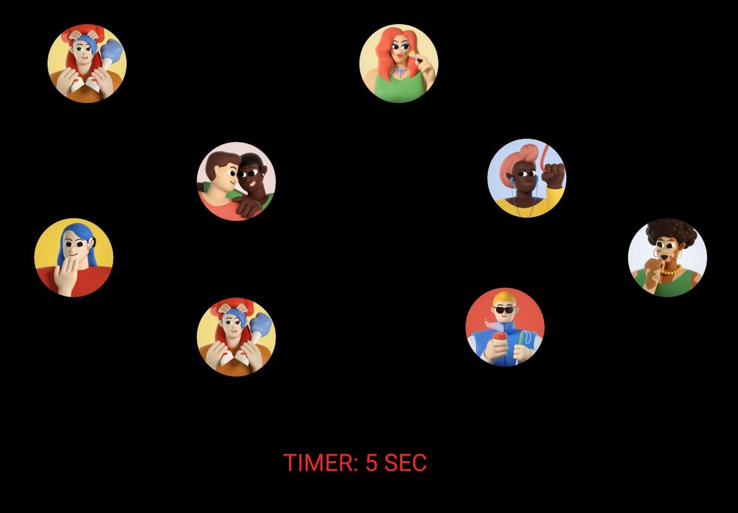

1. **Recall Phase**

**Step 1: Create a New Frame for Recall:**

* + This is where the user will recall the items they saw in the previous chunking phase.

**Step 2: Recall Input (Text Input):**

* + Create Text Input Fields where users can type what they remember. • Create 5 input fields depending on how many chunks you showed.

**Step 3: Submit Button:**

* + Create a Submit button at the bottom using the Rectangle Tool (R) and adding text like “Submit”
  + Add an interaction to move to the Feedback Screen after submission.
  + Sample Output of the Visual Appearance of the Recall Phase (Step C) in Figma **OUTPUT:**

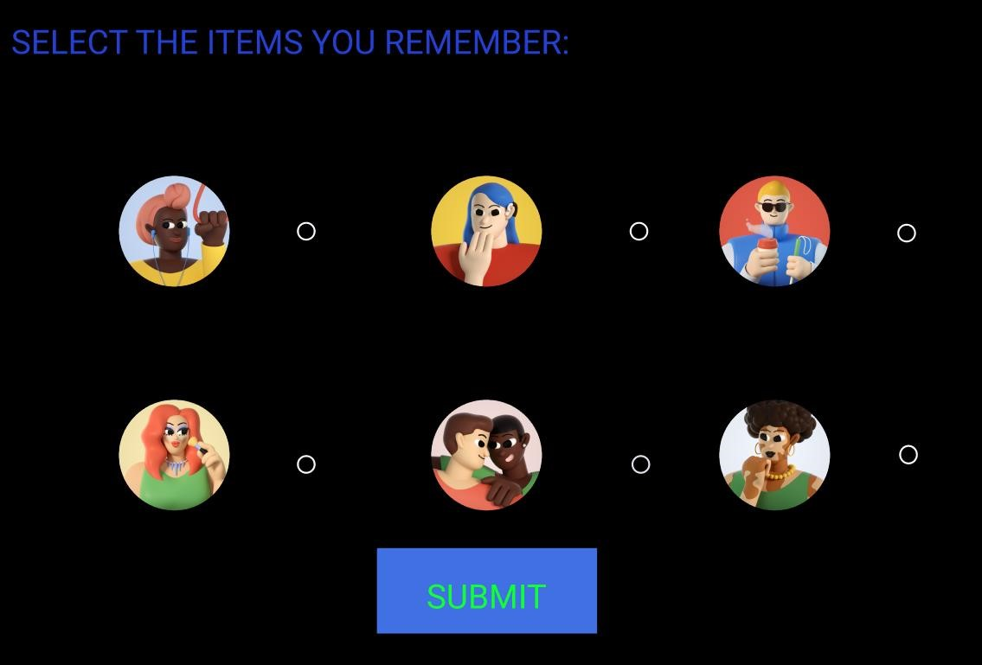

1. **Result Screen**

**Create a Feedback Screen:**

* + After the user submits their recall, provide feedback.
  + Add text like: “Good job you remembered 5/5”

**OUTPUT:**

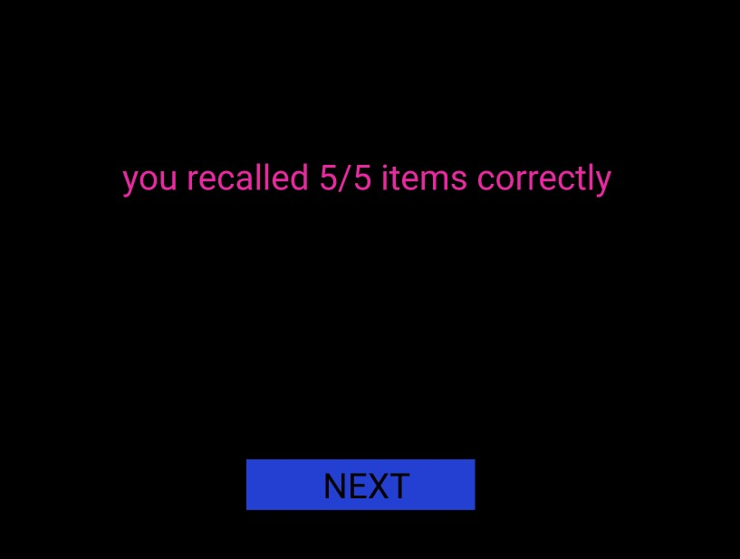

**RESULT:**

Hence , memory recall task using chunking method was studied successfully.